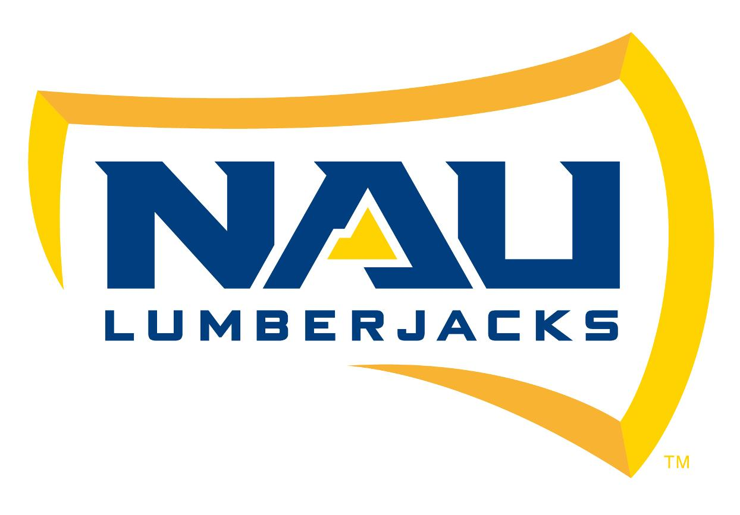

December 13, 2016
Thomas Runyon
Hydrologist, Flagstaff & Mogollon Rim Ranger Districts
Forest Service
Coconino National Forest
5075 N. Highway 89
Flagstaff, AZ 86004

RE: Capstone Proposal

Dear Mr. Runyon,

We are writing to inform you of our interest in the Allan Lake project. Attached is our project proposal for Allan Lake. Questions relating to any technical aspects of the proposal should be directed to us. Questions regarding the administrative nature may also be directed to us at Team Flaming Bunnies, at 253-620-0158.

Your consideration of our proposal is greatly appreciated.

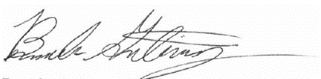
Respectively,
Brando Gutierrez
Team Flaming Bunnies Project Manager

